UNIT -I
1. Structure of C++ Program ?
Ans:
Program Structure of a simple C++ program contains a header file, a function main(), then program code. Here is the program structure of a simple C++ program:
header files
return_type main()
{
program_code_statements;
}

Simple C++ Program :

// my first program in C++
#include <iostream>

int main()
{
cout << "Hello World!";
}
Line 1: // my first program in C++
Two slash signs indicate that the rest of the line is a comment inserted by the programmer but which has no effect on the behavior of the program. Programmers use them to include short explanations or observations concerning the code or program. In this case, it is a brief introductory description of the program.

Line 2: #include <iostream>
Lines beginning with a hash sign (#) are directives read and interpreted by what is known as the preprocessor. They are special lines interpreted before the compilation of the program itself begins. In this case, the directive #include <iostream>, instructs the preprocessor to include a section of standard C++ code, known as header iostream, that allows to perform standard input and output operations, such as writing the output of this program (Hello World) to the screen.

Line 3: A blank line.
Blank lines have no effect on a program. They simply improve readability of the code.

Line 4: int main ()
This line initiates the declaration of a function. Essentially, a function is a group of code statements which are given a name: in this case, this gives the name "main" to the group of code statements that follow. Functions will be discussed in detail in a later chapter, but essentially, their definition is introduced with a succession of a type (int), a name (main) and a pair of parentheses (()), optionally including parameters.
The function named main is a special function in all C++ programs; it is the function called when the program is run. The execution of all C++ programs begins with the main function, regardless of where the function is actually located within the code.

Lines 5 and 7: { and }
The open brace ({) at line 5 indicates the beginning of main's function definition, and the closing brace (}) at line 7, indicates its end. Everything between these braces is the function's body that defines what happens when main is called. All functions use braces to indicate the beginning and end of their definitions.

Line 6: std::cout << "Hello World!";
This line is a C++ statement. A statement is an expression that can actually produce some effect. It is the meat of a program, specifying its actual behavior. Statements are executed in the same order that they appear within a function's body.
Notice that the statement ends with a semicolon (;). This character marks the end of the statement, just as the period ends a sentence in English. All C++ statements must end with a semicolon character. One of the most common syntax errors in C++ is forgetting to end a statement with a semicolon.

2.Tokens of C++

Ans :

C++ Tokens
1.5
A token is the smallest element of a program that is meaningful to the compiler. Tokens can be classified as follows:
- Keywords
- Identifiers
- Constants
- Strings
- Special Symbols
- Operators
  - Keyword: Keywords are pre-defined or reserved words in a programming language. Each keyword is meant to perform a specific function in a program. Since keywords are referred names for a compiler, they can’t be used as variable names because by doing so, we are trying to assign a new meaning to the keyword which is not allowed. You cannot redefine keywords. However, you can specify text to be substituted for keywords before compilation by using C/C++ preprocessor directives. C++ there are 31 additional keywords other than C Keywords they are:

asm bool catch class
const_cast delete dynamic_cast explicit
export false friend inline
mutable namespace new operator
private protected public reinterpret_cast
static_cast template this throw
true try typeid typename
using virtual wchar_t
  - Identifiers: Identifiers are used as the general terminology for naming of variables, functions and arrays. These are user defined names consisting of arbitrarily long sequence of letters and digits with either a letter or the underscore(_) as a first character. Identifier names must differ in spelling and case from any keywords. You cannot use keywords as identifiers; they are reserved for special use. Once declared, you can use the identifier in later program statements to refer to the associated value. A special kind of identifier, called a statement label, can be used in goto statements.
There are certain rules that should be followed while naming c identifiers:
    - They must begin with a letter or underscore(_).
    - They must consist of only letters, digits, or underscore. No other special character is allowed.
    - It should not be a keyword.
    - It must not contain white space.
    - It should be up to 31 characters long as only first 31 characters are significant.
  - Constants: Constants are also like normal variables. But, only difference is, their values can not be modified by the program once they are defined. Constants refer to fixed values. They are also called as literals.
Constants may belong to any of the data type.Syntax:
const
data_type variable_name; (or) const data_type *variable_name;
Types of Constants:
1. Integer constants – Example: 0, 1, 1218, 12482
2. Real or Floating point constants – Example: 0.0, 1203.03, 30486.184
3. Octal & Hexadecimal constants – Example: octal: (013 )₈ = (11)_{10,} Hexadecimal: (013)₁₆ = (19)₁₀
4. Character constants -Example: ‘a’, ‘A’, ‘z’
5. String constants -Example: “GeeksforGeeks”
4. Strings: Strings are nothing but an array of characters ended with a null character (‘\0’).This null character indicates the end of the string. Strings are always enclosed in double quotes. Whereas, a character is enclosed in single quotes in C and C++.Declarations for String:
    - char string[20] = {‘g’, ’e’, ‘e’, ‘k’, ‘s’, ‘f’, ‘o’, ‘r’, ‘g’, ’e’, ‘e’, ‘k’, ‘s’, ‘\0’};
    - char string[20] = “geeksforgeeks”;
    - char string [] = “geeksforgeeks”;
5.Special Symbols: The following special symbols are used in C having some special meaning and thus, cannot be used for some other purpose.[] () {}, ; * = #
    - Brackets[]: Opening and closing brackets are used as array element reference. These indicate single and multidimensional subscripts.
    - Parentheses(): These special symbols are used to indicate function calls and function parameters.
    - Braces{}: These opening and ending curly braces marks the start and end of a block of code containing more than one executable statement.
    - comma (, ): It is used to separate more than one statements like in for loop is separates initialization, condition and increment.
    - semi colon : It is an operator that essentially invokes something called an initialization list.
    - asterick (*): It is used to create pointer variable.
    - assignment operator: It is used to assign values.
    - pre processor(#): The preprocessor is a macro processor that is used automatically by the compiler to transform your program before actual compilation.
6. Operators: Operators are symbols that triggers an action when applied to C variables and other objects. The data items on which operators act upon are called operands.
Depending on the number of operands that an operator can act upon, operators can be classified as follows:
    - Unary Operators: Those operators that require only single operand to act upon are known as unary operators.For Example increment and decrement operators
    - Binary Operators: Those operators that require two operands to act upon are called binary operators. Binary operators are classified into :
      - Arithmetic operators
      - Relational Operators
      - Logical Operators
      - Assignment Operators
      - Conditional Operators
      - Bitwise Operators
3. Break and Continue , goto Statements
Ans :
In C++, there are two statements break; and continue; specifically to alter the normal flow of a program.
Sometimes, it is desirable to skip the execution of a loop for a certain test condition or terminate it immediately without checking the condition.
For example: You want to loop through data of all aged people except people aged 65. Or, you want to find the first person aged 20.
In scenarios like these, continue; or a break; statement is used.

C++ break Statement
The break; statement terminates a loop (for, while and do..while loop) and a switch statement immediately when it appears.

Syntax of break
break;
In real practice, break statement is almost always used inside the body of conditional statement (if...else) inside the loop.

How break statement works?
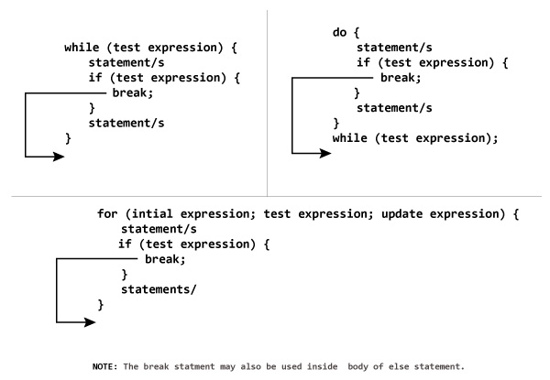
#include <iostream>
using namespace std;
int main() {
float number, sum = 0.0;
// test expression is always true
while (true)
{
cout << "Enter a number: ";
cin >> number;
if (number != 0.0)
{
sum += number;
}
else
{
// terminates the loop if number equals 0.0
break;
}
}
cout << "Sum = " << sum;
return 0;
}
Output
Enter a number: 4
Enter a number: 3.4
Enter a number: 6.7
Enter a number: -4.5
Enter a number: 0
Sum = 9.6
In the above program, the test expression is always true.
The user is asked to enter a number which is stored in the variable number. If the user enters any number other than 0, the number is added to sum and stored to it.
Again, the user is asked to enter another number. When user enters 0, the test expression inside if statement is false and body of else is executed which terminates the loop.
Finally, the sum is displayed.

C++ continue Statement
It is sometimes necessary to skip a certain test condition within a loop. In such case, continue; statement is used in C++ programming.

Syntax of continue
continue;
In practice, continue; statement is almost always used inside a conditional statement.

Working of continue Statement
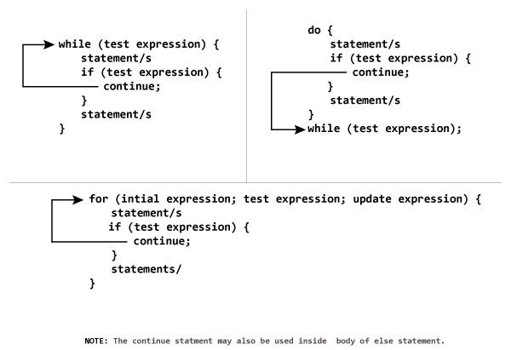
#include <iostream>
using namespace std;
int main()
{
for (int i = 1; i <= 10; ++i)
{
if ( i == 6 || i == 9)
{
continue;
}
cout << i << "\t";
}
return 0;
}
Output
1 2 3 4 5 7 8 10
In above program, when i is 6 or 9, execution of statement cout << i << "\t"; is skipped inside the loop using continue; statement.
Goto Statement:
In C++ programming, goto statement is used for altering the normal sequence of program execution by transferring control to some other part of the program.

Syntax of goto Statement
goto label;
... .. ...
... .. ...
... .. ...
label:
statement;
... .. ...
In the syntax above, label is an identifier. When goto label; is encountered, the control of program jumps to label: and executes the code below it.
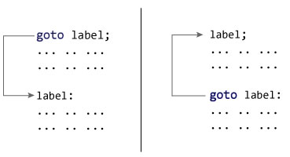

Example: goto Statement
# include <iostream>
using namespace std;
int main()
{
float num, average, sum = 0.0;
int i, n;
cout << "Maximum number of inputs: ";
cin >> n;
for(i = 1; i <= n; ++i)
{
cout << "Enter n" << i << ": ";
cin >> num;
if(num < 0.0)
{
// Control of the program move to jump:
goto jump;
}
sum += num;
}
jump:
average = sum / (i - 1);
cout << "\nAverage = " << average;
return 0;
}
Output
Maximum number of inputs: 10
Enter n1: 2.3
Enter n2: 5.6
Enter n3: -5.6

Average = 3.95
You can write any C++ program without the use of goto statement and is generally considered a good idea not to use them.

UNIT- II
1. Explain the functions of C++?
Ans: Functions are used to provide modularity to a program. Creating an application using function makes it easier to understand, edit, check errors etc.
Syntax of Function :
return-type function-name (parameters)
{
// function-body
}
return-type : suggests what the function will return. It can be int, char, some pointer or even a class object. There can be functions which does not return anything, they are mentioned with void.
Function Name : is the name of the function, using the function name it is called.
Parameters : are variables to hold values of arguments passed while function is called. A function may or may not contain parameter list.
void sum(int x, int y)
{
int z;
z = x + y;
cout << z;
}
int main()
{
int a = 10;
int b = 20;
sum (a, b);
}
Here, a and b are sent as arguments, and x and y are parameters which will hold values of a and b to perform required operation inside function.
Function body : is he part where the code statements are written.
2. Types of Functions
Ans:
Functions are two types :
- Library Function
- User-defined Function

Library Function
Library functions are the built-in function in C++ programming.
Programmer can use library function by invoking function directly; they don't need to write it themselves.

Example 1: Library Function
#include <iostream>
#include <cmath>

using namespace std;

int main()
{
double number, squareRoot;
cout << "Enter a number: ";
cin >> number;

// sqrt() is a library function to calculate square root
squareRoot = sqrt(number);
cout << "Square root of " << number << " = " << squareRoot;
return 0;
}
Output
Enter a number: 26
Square root of 26 = 5.09902
In the example above, sqrt() library function is invoked to calculate the square root of a number.
Here, cmath is a header file. The function definition of sqrt()(body of that function) is present in the cmath header file.
You can use all functions defined in cmath when you include the content of file cmath in this program using #include <cmath> .
Every valid C++ program has at least one function, that is, main() function.

2. User-defined Function
C++ allows programmer to define their own function.
A user-defined function groups code to perform a specific task and that group of code is given a name(identifier).
When the function is invoked from any part of program, it all executes the codes defined in the body of function.

How user-defined function works in C Programming?
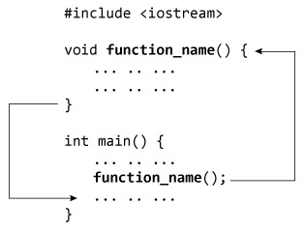
When a program begins running, the system calls the main() function, that is, the system starts executing codes from main() function.
When control of the program reaches to function_name() inside main(), it moves to void function_name() and all codes inside void function_name() is executed.
Then, control of the program moves back to the main function where the code after the call to the function_name() is executed as shown in figure above.
#include <iostream>
using namespace std;

// Function prototype (declaration)
int add(int, int);

int main()
{
int num1, num2, sum;
cout<<"Enters two numbers to add: ";
cin >> num1 >> num2;

// Function call
sum = add(num1, num2);
cout << "Sum = " << sum;
return 0;
}

// Function definition
int add(int a, int b)
{
int add;
add = a + b;

// Return statement
return add;
}
Output
Enters two integers: 8
-4
Sum = 4

Function prototype (declaration)
If a user-defined function is defined after main() function, compiler will show error. It is because compiler is unaware of user-defined function, types of argument passed to function and return type.
In C++, function prototype is a declaration of function without its body to give compiler information about user-defined function. Function prototype in the above example is:
int add(int, int);
You can see that, there is no body of function in prototype. Also, there are only return type of arguments but no arguments. You can also declare function prototype as below but it's not necessary to write arguments.
int add(int a, int b);
3. How to call a Function?
Ans: Functions are called by their names. if the function is without argument it can be called directly using its name. But functions with arguments, we have two ways to call them.
1. Call by Value
2. Call by reference
1. Call by Value:
The call by Value method of passing arguments to a function , the actual Values of an argument into the formal parameter. changes made to the parameter inside the function have no effect on the argument.
Example:

#include<iostream.h>
#include<conio.h>

void swap(int a, int b)
{
int temp;
temp=a;
a=b;
b=temp;
}

void main()
{
int a=100, b=200;
clrscr();
swap(a, b); // passing value to function
cout<<"Value of a"<<a;
cout<<"Value of b"<<b;
getch();
}
Output
Value of a: 200
Value of b: 100

2. Call by reference:
The call by reference method of passing arguments to a function copies the address of an argument into the formal parameter. the actual value of the argument is not passed. Instead, only the reference to that value is passed. It means the changes made to the parameter affect the passed argument.
In call by reference, original value is modified because we pass reference (address).
Example :
include<iostream.h>
#include<conio.h>
void swap(int *a, int *b)
{
int temp;
temp=*a;
*a=*b;
*b=temp;
}
void main()
{
int a=100, b=200;
clrscr();
swap(&a, &b); // passing value to function
cout<<"Value of a"<<a;
cout<<"Value of b"<<b;
getch();
}
Output
Value of a: 200
Value of b: 100
4. Scope of variable:
Ans: While writing code you need various variables. Variables have their own boundaries where those are accessible. Outside those boundaries variables don't hold their values. These boundaries are known as scope of variable. It is important to know the lifetime and scope of variables. The Variables Scope can be divided into two categories:
- Global Variables
- Local Variables

Global variables
Global variables are variables that are often declared outside the main() function. The variable scope is the full file where the variable is defined. The global variable can be defined as below:
//include a header file from Standard Library
#include
using namespace std;
//This is GLOBAL VARIABLE
int weight;
//the work of the program starts from function called main
int main()
{
weight = 3; //Now weight is equal to 3
cout << "Weight is " << weight << endl;
cin.ignore();
return 0;
}
You will understand better the Global Variable Scope when you will learn functions and more advanced C++ topics. For you now it's more important to understand the meaning of the local variable.

Local Variables
Global variables are accessible in full file. But local variables are not accessible in full file. The local variable's scope is between the block of instruction that is defined between "{" and "}". Take a look on this example:
int main()
{
{
double price = 2.0,
height = 3.1,
length = 2.4;
cout << "Price is " << price << endl;
cout << "Length is " << length << endl;
cout << "Height is " << height << endl;
}
weight = 3; //Now weight is equal to 3
cin.ignore();
return 0;
}
As you can see, price, height and length are defined in a separate block in the main function. And all the operations are performed in the same block. Try to run this program. It will be executed without any problems.
5. Storage class :
Ans: A storage class defines the scope (visibility) and life-time of variables and/or functions within a C++ Program. These specifiers precede the type that they modify. There are following storage classes, which can be used in a C++ Program
- auto
- register
- static
- extern
- mutable

The auto Storage Class
The auto storage class is the default storage class for all local variables.
{
int mount;
auto int month;
}
The example above defines two variables with the same storage class, auto can only be used within functions, i.e., local variables.

The register Storage Class
The register storage class is used to define local variables that should be stored in a register instead of RAM. This means that the variable has a maximum size equal to the register size (usually one word) and can't have the unary '&' operator applied to it (as it does not have a memory location).
{
register int miles;
}
The register should only be used for variables that require quick access such as counters. It should also be noted that defining 'register' does not mean that the variable will be stored in a register. It means that it MIGHT be stored in a register depending on hardware and implementation restrictions.

The static Storage Class
The static storage class instructs the compiler to keep a local variable in existence during the life-time of the program instead of creating and destroying it each time it comes into and goes out of scope. Therefore, making local variables static allows them to maintain their values between function calls.
The static modifier may also be applied to global variables. When this is done, it causes that variable's scope to be restricted to the file in which it is declared.
In C++, when static is used on a class data member, it causes only one copy of that member to be shared by all objects of its class.
#include <iostream>

// Function declaration
void func(void);

static int count = 10; /* Global variable */

main() {
while(count--) {
func();
}

return 0;
}

// Function definition
void func( void ) {
static int i = 5; // local static variable
i++;
std::cout << "i is " << i ;
std::cout << " and count is " << count << std::endl;
}
When the above code is compiled and executed, it produces the following result −
i is 6 and count is 9
i is 7 and count is 8
i is 8 and count is 7
i is 9 and count is 6
i is 10 and count is 5
i is 11 and count is 4
i is 12 and count is 3
i is 13 and count is 2
i is 14 and count is 1
i is 15 and count is 0

The extern Storage Class
The extern storage class is used to give a reference of a global variable that is visible to ALL the program files. When you use 'extern' the variable cannot be initialized as all it does is point the variable name at a storage location that has been previously defined.
When you have multiple files and you define a global variable or function, which will be used in other files also, then extern will be used in another file to give reference of defined variable or function. Just for understanding extern is used to declare a global variable or function in another file.
The extern modifier is most commonly used when there are two or more files sharing the same global variables or functions as explained below.

First File: main.cpp
#include <iostream>

int count ;
extern void write_extern();

main() {
count = 5;
write_extern();
}

Second File: support.cpp
#include <iostream>

extern int count;

void write_extern(void) {
std::cout << "Count is " << count << std::endl;
}
Here, extern keyword is being used to declare count in another file. Now compile these two files as follows −
This will produce write executable program, try to execute write and check the result as follows −

The mutable Storage Class
The mutable specifier applies only to class objects, which are discussed later in this tutorial. It allows a member of an object to override const member function. That is, a mutable member can be modified by a const member function.
6. Recursive Function :
A function that calls itself is known as recursive function. And, this technique is known as recursion.
The figure below shows how recursion works by calling itself over and over again.
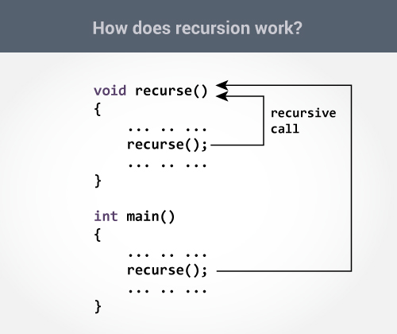
The recursion continues until some condition is met.
To prevent infinite recursion, if...else statement (or similar approach) can be used where one branch makes the recursive call and other doesn't.

Factorial of a Number Using Recursion
// Factorial of n = 1*2*3*...*n

#include <iostream>
using namespace std;

int factorial(int);

int main()
{
int n;
cout<<"Enter a number to find factorial: ";
cin >> n;
cout << "Factorial of " << n <<" = " << factorial(n);
return 0;
}

int factorial(int n)
{
if (n > 1)
{
return n*factorial(n-1);
}
else
{
return 1;
}
}
Output
Enter a number to find factorial: 4
Factorial of 4 = 24

Explanation: How this example works?
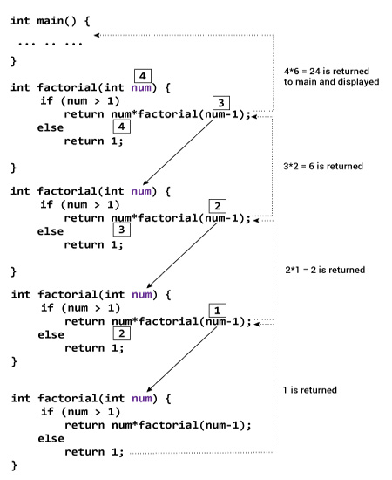
Suppose the user entered 4, which is passed to the factorial() function.
- In the first factorial() function, test expression inside if statement is true. The return num*factorial(num-1); statement is executed, which calls the second factorial() function and argument passed is num-1which is 3.
- In the second factorial() function, test expression inside if statement is true. The return num*factorial(num-1); statement is executed, which calls the third factorial() function and argument passed is num-1 which is 2.
- In the third factorial() function, test expression inside if statement is true. The return num*factorial(num-1); statement is executed, which calls the fourth factorial() function and argument passed is num-1 which is 1.
- In the fourth factorial() function, test expression inside if statement is false. The return 1; statement is executed, which returns 1 to third factorial() function.
- The third factorial() function returns 2 to the second factorial() function.
- The second factorial() function returns 6 to the first factorial() function.
- Finally, the first factorial() function returns 24 to the main() function, which is displayed on the screen.
7. Function Overloading …
Ans: Function refers to a segment that groups code to perform a specific task.
In C++ programming, two functions can have same name if number and/or type of arguments passed are different.
These functions having different number or type (or both) of parameters are known as overloaded functions. For example:
int test() { }
int test(int a) { }
float test(double a) { }
int test(int a, double b) { }
Here, all 4 functions are overloaded functions because argument(s) passed to these functions are different.
Notice that, the return type of all these 4 functions are not same. Overloaded functions may or may not have different return type but it should have different argument(s).
// Error code
int test(int a) { }
double test(int b){ }
The number and type of arguments passed to these two functions are same even though the return type is different. Hence, the compiler will throw error.

Example 1: Function Overloading
#include <iostream>
using namespace std;

void display(int);
void display(float);
void display(int, float);

int main() {

int a = 5;
float b = 5.5;

display(a);
display(b);
display(a, b);

return 0;
}

void display(int var) {
cout << "Integer number: " << var << endl;
}

void display(float var) {
cout << "Float number: " << var << endl;
}

void display(int var1, float var2) {
cout << "Integer number: " << var1;
cout << " and float number:" << var2;
}
Output
Integer number: 5
Float number: 5.5
Integer number: 5 and float number: 5.5
Here, the display() function is called three times with different type or number of arguments.
8. Array :
Ans : An array is a collection of similar data type value in a single variable. It is a derived data type in C++, which is constructed from fundamental data type of C++ language.
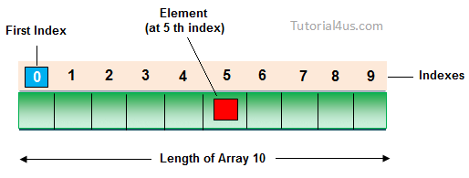

Declaring Array
To declare an array in C++ required type of array elements and size of array.

Syntax

Datatype arrayName[SIZE];

Initializing Array
Initializing is a process to initialize the value in array variable. This is happen in two ways, initialize array one by one or all elements are initializing once.

Initialization of array one by one

int arr[5];
arr[0]=10;
arr[1]=20;
arr[2]=30;
arr[3]=40;
arr[4]=50;

Initialization of array at once

int arr[]={10,20,30,40,50};

Example of Array in C++

#include<iostream.h>
#include<conio.h>

void main()
{
int i, marks[]={80, 62, 70, 90, 98}; //declaration and initialization of array
clrscr();

//traversal of array
for(i=0;i<5;i++)
{
cout<<endl<<marks[i];
}
getch();
}

Output

80
62
70
90
98
Types of array..
There are two types of arrays :
1. Single Dimensional Array
2. Multi Dimensional Array
1. Single Dimensional Array :
A dimensional is used representing the elements of the array for example
int a[5]
The [] is used for dimensional or the sub-script of the array that is generally used for declaring the elements of the array For Accessing the Element from the array we can use the Subscript of the Array like this
a[3]=100
This will set the value of 4th element of array
So there is only the single bracket then it called the Single Dimensional Array
This is also called as the Single Dimensional Array
Example :
#include <iostream>
using namespace std;
int main()
{
int numbers[5], sum = 0;
cout << "Enter 5 numbers: ";
// Storing 5 number entered by user in an array
// Finding the sum of numbers entered
for (int i = 0; i < 5; ++i)
{
cin >> numbers[i];
sum += numbers[i];
}
cout << "Sum = " << sum << endl;
return 0;
}
Output
Enter 5 numbers: 3
4
5
4
2
Sum = 18
2. Multi Dimensional Array :
The simplest form of the multidimensional array is the two-dimensional array. A two-dimensional array is, in essence, a list of one-dimensional arrays. To declare a two-dimensional integer array of size x,y, you would write something as follows −
type arrayName [ x ][ y ];
Where type can be any valid C++ data type and arrayName will be a valid C++ identifier.
A two-dimensional array can be think as a table, which will have x number of rows and y number of columns. A 2-dimensional array a, which contains three rows and four columns can be shown as below −
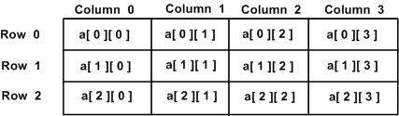
Thus, every element in array a is identified by an element name of the form a[ i ][ j ], where a is the name of the array, and i and j are the subscripts that uniquely identify each element in a.
Example :
#include <iostream>
using namespace std;

int main()
{
int test[3][2] =
{
{2, -5},
{4, 0},
{9, 1}
};

// Accessing two dimensional array using
// nested for loops
for(int i = 0; i < 3; ++i)
{
for(int j = 0; j < 2; ++j)
{
cou t<< "test[" << i << "][" << j << "] = " << test[i][j] << endl;
}
}

return 0;
}
Output
test[0][0] = 2
test[0][1] = -5
test[1][0] = 4
test[1][1] = 0
test[2][0] = 9
test[2][1] = 1
9.Pointer Variable :
Ans : A pointer is a variable whose value is the address of another variable. Like any variable or constant, you must declare a pointer before you can work with it. The general form of a pointer variable declaration is −
type *var-name;
Here, type is the pointer's base type; it must be a valid C++ type and var-name is the name of the pointer variable. The asterisk you used to declare a pointer is the same asterisk that you use for multiplication. However, in this statement the asterisk is being used to designate a variable as a pointer
The actual data type of the value of all pointers, whether integer, float, character, or otherwise, is the same, a long hexadecimal number that represents a memory address. The only difference between pointers of different data types is the data type of the variable or constant that the pointer points to.

Using Pointers in C++
There are few important operations, which we will do with the pointers very frequently. (a) We define a pointer variable. (b) Assign the address of a variable to a pointer. (c) Finally access the value at the address available in the pointer variable. This is done by using unary operator * that returns the value of the variable located at the address specified by its operand. Following example makes use of these operations −
#include <iostream>

using namespace std;

int main () {
int var = 20; // actual variable declaration.
int *ip; // pointer variable

ip = &var; // store address of var in pointer variable

cout << "Value of var variable: ";
cout << var << endl;

// print the address stored in ip pointer variable
cout << "Address stored in ip variable: ";
cout << ip << endl;

// access the value at the address available in pointer
cout << "Value of *ip variable: ";
cout << *ip << endl;

return 0;
}
When the above code is compiled and executed, it produces result something as follows −
Value of var variable: 20
Address stored in ip variable: 0xbfc601ac
Value of *ip variable: 20
10. Passing pointers to Functions :
Ans : One of the uses of pointer variables in C++ is in passing arguments to functions. To understand why this is important, you need to understand how arguments are passed to a function.

Passing by value in C++
By default, arguments are passed to functions by value. This has the somewhat surprising result that changing the value of a variable in a function does not normally change its value in the calling function. Consider the following example code segment:
void fn(int nArg)
{
nArg = 10;
// value of nArg at this point is 10
}
void parent(void)
{
int n1 = 0;
fn(n1);
// value of n1 at this point is still 0
}
Here the parent() function initializes the integer variable n1 to 0. The value of n1 is then passed to fn(). Upon entering the function, nArg is equal to 0, the value passed. fn() changes the value of nArg to 10 before returning to parent(). Upon returning to parent(), the value of n1 is still 0.
The reason for this behavior is that C++ doesn’t pass a variable to a function. Instead, C++ passes the value contained in the variable at the time of the call. That is, the expression is evaluated, even if it is just a variable name, and the result is passed.
In the example, the value of n1, which is 0, was passed to fn(). What the function does with that value has no effect on n1.

Passing pointer values in C++
Like any other intrinsic type, a pointer may be passed as an argument to a function:
void fn(int* pnArg)
{
*pnArg = 10;
}
void parent(void)
{
int n = 0;
fn(&n); // this passes the address of i
// now the value of n is 10
}
In this case, the address of n is passed to the function fn() rather than the value of n. The significance of this difference is apparent when you consider the assignment within fn().
Suppose n is located at address 0x100. Rather than the value 10, the call fn(&n) passes the value 0x100. Within fn(), the assignment *pnArg = 10 stores the value 10 in the int variable located at location 0x100, thereby overwriting the value 0. Upon returning to parent(), the value of n is 10 because n is just another name for 0x100.
11.Dynamic Memory allocation :
Ans:
Memory in your C++ program is divided into two parts −
- The stack − All variables declared inside the function will take up memory from the stack.
- The heap − This is unused memory of the program and can be used to allocate the memory dynamically when program runs.
Many times, you are not aware in advance how much memory you will need to store particular information in a defined variable and the size of required memory can be determined at run time.
You can allocate memory at run time within the heap for the variable of a given type using a special operator in C++ which returns the address of the space allocated. This operator is called new operator.
If you are not in need of dynamically allocated memory anymore, you can use delete operator, which de-allocates memory that was previously allocated by new operator.

new and delete Operators
There is following generic syntax to use new operator to allocate memory dynamically for any data-type.
new data-type;
Here, data-type could be any built-in data type including an array or any user defined data types include class or structure. Let us start with built-in data types. For example we can define a pointer to type double and then request that the memory be allocated at execution time. We can do this using the new operator with the following statements −
double* pvalue = NULL; // Pointer initialized with null
pvalue = new double; // Request memory for the variable
The memory may not have been allocated successfully, if the free store had been used up. So it is good practice to check if new operator is returning NULL pointer and take appropriate action as below −
double* pvalue = NULL;
if( !(pvalue = new double )) {
cout << "Error: out of memory." <<endl;
exit(1);
}
The malloc() function from C, still exists in C++, but it is recommended to avoid using malloc() function. The main advantage of new over malloc() is that new doesn't just allocate memory, it constructs objects which is prime purpose of C++.
At any point, when you feel a variable that has been dynamically allocated is not anymore required, you can free up the memory that it occupies in the free store with the ‘delete’ operator as follows −
delete pvalue; // Release memory pointed to by pvalue
Let us put above concepts and form the following example to show how ‘new’ and ‘delete’ work −
#include <iostream>
using namespace std;

int main () {
double* pvalue = NULL; // Pointer initialized with null
pvalue = new double; // Request memory for the variable

*pvalue = 29494.99; // Store value at allocated address
cout << "Value of pvalue : " << *pvalue << endl;

delete pvalue; // free up the memory.

return 0;
}
If we compile and run above code, this would produce the following result −
Value of pvalue : 29495

Dynamic Memory Allocation for Arrays
Consider you want to allocate memory for an array of characters, i.e., string of 20 characters. Using the same syntax what we have used above we can allocate memory dynamically as shown below.
char* pvalue = NULL; // Pointer initialized with null
pvalue = new char[20]; // Request memory for the variable
To remove the array that we have just created the statement would look like this −
delete [] pvalue; // Delete array pointed to by pvalue
Following the similar generic syntax of new operator, you can allocate for a multi-dimensional array as follows −
double** pvalue = NULL; // Pointer initialized with null
pvalue = new double [3][4]; // Allocate memory for a 3x4 array
However, the syntax to release the memory for multi-dimensional array will still remain same as above −
delete [] pvalue; // Delete array pointed to by value

UNIT-III
1. Declaring, accessing structure in C++
Ans:
C++ arrays allow you to define variables that combine several data items of the same kind, but structure is another user defined data type which allows you to combine data items of different kinds.
Structures are used to represent a record, suppose you want to keep track of your books in a library. You might want to track the following attributes about each book −
- Title
- Author
- Subject
- Book ID

Defining a Structure
To define a structure, you must use the struct statement. The struct statement defines a new data type, with more than one member, for your program. The format of the struct statement is this −
struct [structure tag] {
member definition;
member definition;
...
member definition;
} [one or more structure variables];
The structure tag is optional and each member definition is a normal variable definition, such as int i; or float f; or any other valid variable definition. At the end of the structure's definition, before the final semicolon, you can specify one or more structure variables but it is optional. Here is the way you would declare the Book structure −
struct Books {
char title[50];
char author[50];
char subject[100];
int book_id;
} book;

Accessing Structure Members
To access any member of a structure, we use the member access operator (.). The member access operator is coded as a period between the structure variable name and the structure member that we wish to access. You would use struct keyword to define variables of structure type.

2. How to access the Data members of a class and Member functions of a Class..?
Ans:

Accessing Data Members of Class

Accessing a data member depends solely on the access control of that data member. If its public, then the data member can be easily accessed using the direct member access (.) operator with the object of that class.
If, the data member is defined as private or protected, then we cannot access the data variables directly. Then we will have to create special public member functions to access, use or initialize the private and protected data members. These member functions are also called Accessors and Mutator methods or getter and setter functions.

Accessing Public Data Members
Following is an example to show you how to initialize and use the public data members using the dot (.) operator and the respective object of class.
class Student
{
public:
int rollno;
string name;
};

int main()
{
Student A;
Student B;
A.rollno=1;
A.name="Adam";

B.rollno=2;
B.name="Bella";

cout <<"Name and Roll no of A is :"<< A.name << A.rollno;
cout <<"Name and Roll no of B is :"<< B.name << B.rollno;
}

Accessing Private Data Members
To access, use and initialize the private data member you need to create getter and setter functions, to get and set the value of the data member.
The setter function will set the value passed as argument to the private data member, and the getter function will return the value of the private data member to be used. Both getter and setter function must be defined public.
Example :
class Student
{
private: // private data member
int rollno;

public: // public accessor and mutator functions
int getRollno()
{
return rollno;
}

void setRollno(int i)
{
rollno=i;
}

};

int main()
{
Student A;
A.rollono=1; //Compile time error
cout<< A.rollno; //Compile time error

A.setRollno(1); //Rollno initialized to 1
cout<< A.getRollno(); //Output will be 1
}
So this is how we access and use the private data members of any class using the getter and setter methods. We will discuss this in more details later.

Accessing Protected Data Members
Protected data members, can be accessed directly using dot (.) operator inside the subclass of the current class, for non-subclass we will have to follow the steps same as to access private data member.
3.Explain constructor overloading ?
Ans:
A constructor is a special type of member function that initialises an object automatically when it is created.
n C++, We can have more than one constructor in a class with same name, as long as each has a different list of arguments.This concept is known as Constructor Overloading and is quite similar to function overloading.
- Overloaded constructors essentially have the same name (name of the class) and different number of arguments.
- A constructor is called depending upon the number and type of arguments passed.
- While creating the object, arguments must be passed to let compiler know, which constructor needs to be called.
// C++ program to illustrate
// Constructor overloading
#include <iostream>
using namespace std;
class construct
{
public:
float area;
// Constructor with no parameters
construct()
{
area = 0;
}
// Constructor with two parameters
construct(int a, int b)
{
area = a * b;
}
void disp()
{
cout<< area<< endl;
}
};
int main()
{
// Constructor Overloading
// with two different constructors
// of class name
construct o;
construct o2( 10, 20);

o.disp();
o2.disp();
return 1;
}
Output:
0
200

4.Destructors :
Ans:

Destructor is a member function which destructs or deletes an object.
A destructor function is called automatically when the object goes out of scope:
(1) the function ends
(2) the program ends
(3) a block containing local variables ends
(4) a delete operator is called
Destructors have same name as the class preceded by a tilde (~)
Destructors don’t take any argument and don’t return anything
class String
{
private:
char *s;
int size;
public:
String(char *); // constructor
~String(); // destructor
};

String::String(char *c)
{
size = strlen(c);
s = new char[size+1];
strcpy(s,c);
}

String::~String()
{
delete []s;
}
No, there can only one destructor in a class with classname preceded by ~, no parameters and no return type.
If we do not write our own destructor in class, compiler creates a default destructor for us. The default destructor works fine unless we have dynamically allocated memory or pointer in class. When a class contains a pointer to memory allocated in class, we should write a destructor to release ..

UNIT- IV
1. Inheritance:
The capability of a class to derive properties and characteristics from another class is called Inheritance. Inheritance is one of the most important feature of Object Oriented Programming.
Sub Class: The class that inherits properties from another class is called Sub class or Derived Class.
Super Class: The class whose properties are inherited by sub class is called Base Class or Super class.
Types of Inheritance in C++
- Single Inheritance: In single inheritance, a class is allowed to inherit from only one class. i.e. one sub class is inherited by one base class only.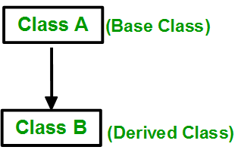
Syntax:
- class subclass_name : access_mode base_class
- {
- //body of subclass
- };
// C++ program to explain
// Single inheritance
#include <iostream>
using namespace std;
// base class
class Vehicle {
public:
Vehicle()
{
cout << "This is a Vehicle" << endl;
}
};
// sub class derived from two base classes
class Car: public Vehicle{
};
// main function
int main()
{
// creating object of sub class will
// invoke the constructor of base classes
Car obj;
return 0;
}
• Output:
This is a vehicle
• Multiple Inheritance: Multiple Inheritance is a feature of C++ where a class can inherit from more than one classes. i.e one sub class is inherited from more than one base classes.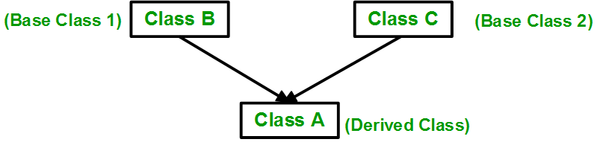
Syntax:
class subclass_name : access_mode base_class1, access_mode base_class2, ....
{
//body of subclass
};
Here, the number of base classes will be separated by a comma (‘, ‘) and access mode for every base class must be specified.
// C++ program to explain
// multiple inheritance
#include <iostream>
using namespace std;

// first base class
class Vehicle {
public:
Vehicle()
{
cout << "This is a Vehicle" << endl;
}
};

// second base class
class FourWheeler {
public:
FourWheeler()
{
cout << "This is a 4 wheeler Vehicle" << endl;
}
};

// sub class derived from two base classes
class Car: public Vehicle, public FourWheeler {

};

// main function
int main()
{
// creating object of sub class will
// invoke the constructor of base classes
Car obj;
return 0;
}
• Output:
This is a Vehicle
This is a 4 wheeler Vehicle
Please visit this link to learn multiple inheritance in details.
• Multilevel Inheritance: In this type of inheritance, a derived class is created from another derived class. 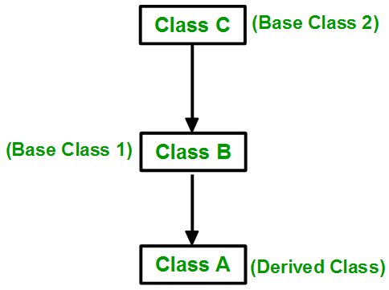
// C++ program to implement
// Multilevel Inheritance
#include <iostream>
using namespace std;

// base class
class Vehicle
{
public:
Vehicle()
{
cout << "This is a Vehicle" << endl;
}
};
class fourWheeler: public Vehicle
{ public:
fourWheeler()
{
cout<<"Objects with 4 wheels are vehicles"<<endl;
}
};
// sub class derived from two base classes
class Car: public fourWheeler{
public:
car()
{
cout<<"Car has 4 Wheels"<<endl;
}
};
// main function
int main()
{
//creating object of sub class will
//invoke the constructor of base classes
Car obj;
return 0;
}
• output:
This is a Vehicle
Objects with 4 wheels are vehicles
Car has 4 Wheels
• Hierarchical Inheritance: In this type of inheritance, more than one sub class is inherited from a single base class. i.e. more than one derived class is created from a single base class.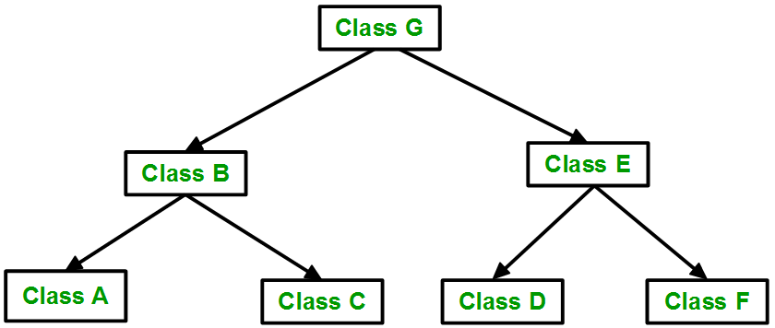
// C++ program to implement
// Hierarchical Inheritance
#include <iostream>
using namespace std;
// base class
class Vehicle
{
public:
Vehicle()
{
cout << "This is a Vehicle" << endl;
}
};
// first sub class
class Car: public Vehicle
{
};
// second sub class
class Bus: public Vehicle
{
};
// main function
int main()
{
// creating object of sub class will
// invoke the constructor of base class
Car obj1;
Bus obj2;
return 0;
}
• Output:
This is a Vehicle
This is a Vehicle
• Hybrid (Virtual) Inheritance: Hybrid Inheritance is implemented by combining more than one type of inheritance. For example: Combining Hierarchical inheritance and Multiple Inheritance.
Below image shows the combination of hierarchical and multiple inheritance: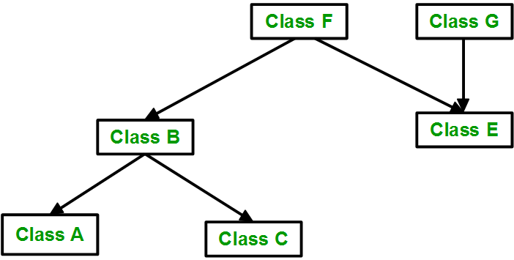
// C++ program for Hybrid Inheritance

#include <iostream>
using namespace std;

// base class
class Vehicle
{
public:
Vehicle()
{
cout << "This is a Vehicle" << endl;
}
};
//base class
class Fare
{
public:
Fare()
{
cout<<"Fare of Vehicle\n";
}
};
// first sub class
class Car: public Vehicle
{
};
// second sub class
class Bus: public Vehicle, public Fare
{
};
// main function
int main()
{
Bus obj2;
return 0;
}
Output:
This is a Vehicle
Fare of Vehicle

